TI-Innovator Hub Data Acquisition Tool

**1. User Guide** **2**

1.1. Introduction 2

1.2. Getting Started: Setup TI Innovator Hub 2

1.4. Connecting the Modules 4

1.3.1. Wifi Module 4

1.3.2. Multimeter and Function Generator Module 4

1.3.3. Oscilloscope Module 5

1.3.4. Logic Analyzer Module 5

1.4. Power On 6

1.5. Connecting to the Wireless Access Point 6

1.6. Running the Graphical User Interface 7

1.6.1. Multimeter 7

1.6.2. Oscilloscope 8

1.6.3. Function Generator 9

1.6.4. Logic Analyzer 9

1.7. Data Acquisition: Multimeter 10

1.8. Data Acquisition: Oscilloscope 10

1.9. Data Acquisition: Logic Analyzer 11

1.10. Driving a Circuit: Function Generator 11

**2. Additional Setup for Prototype (For Mark)** **13**

2.1. Introduction 13

2.2. Setting up ESP32 Firmware (Arduino) 13

2.3. Setting up MSP432P401R Firmware (Code Composer Studio) 16

# 

# 1. User Guide

## 1.1. Introduction

The TI Innovator Hub Data Acquisition Tool is a student and hobbyist level device equipped with a multimeter, a two-channel oscilloscope, an eight-channel logic analyzer, and a four-channel function generator. These modules allow a user to develop and debug entry and intermediate level circuits as they explore the fundamentals of Electrical and Computer Engineering. This kit is an add-on to the already existing TI Innovator Hub.

## 1.2. Getting Started: Setup TI Innovator Hub

1. Ensure you have all the necessary components. You will need a:
   1. microUSB cable

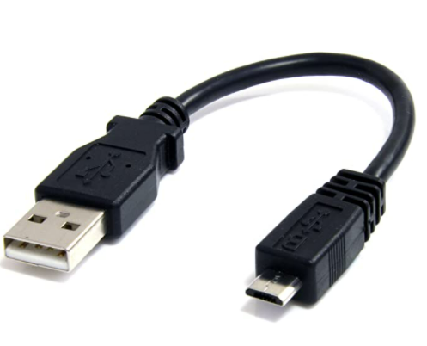

* 1. TI Innovator Hub

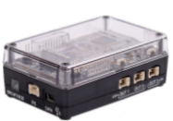

* 1. computer with a web browser.
  2. wifi module

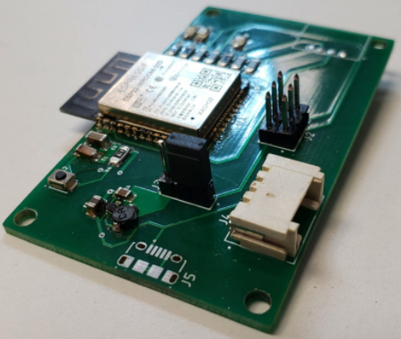

* 1. multimeter module

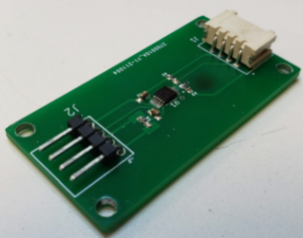

* 1. function generator module

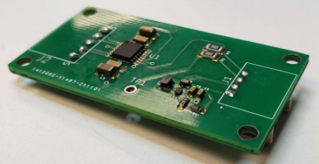

* 1. grove module hub

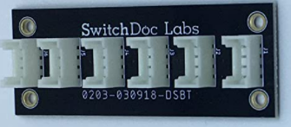

* 1. four female to female grove cables
  2. 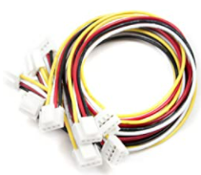
  3. one breadboard connector to female grove cable

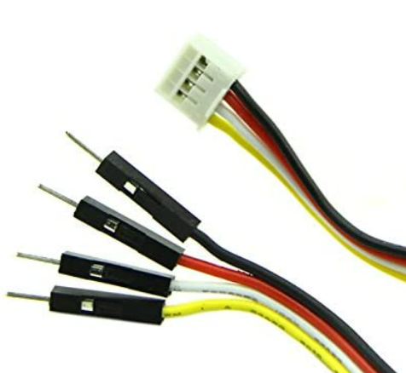

* 1. circuit you wish to measure and breadboard wires.

1. If your TI Innovator Hub does not already have the sketch needed for the modules, please download and flash the TI Innovator Hub with the proper sketch. (This sketch does not exist at the moment) The default sketch on the TI Innovator Hub is not the correct sketch. For those needing to use Arduino and Code Composer Studio, please refer to 2. Additional Setup for Prototype. The TI software needed to update the sketch can be found at this [link](https://education.ti.com/en/software/details/en/EFD1D3762FE941FAA21E774D8520AEF0/TI-Innovator_Hub_Update_SWti).
2. Once the TI Innovator Hub has the correct sketch, leave it unplugged and move on to the next section.

## 1.4. Connecting the Modules

Refer to the images below to properly connect the modules.

### 1.3.1. Wifi Module

The wifi module uses a female to female grove cable and is connected to the OUT1 port.

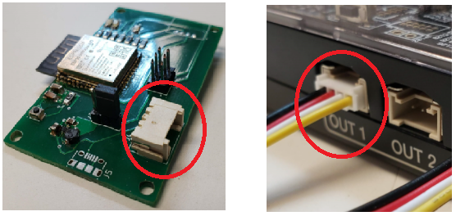

### 1.3.2. Multimeter and Function Generator Module

The multimeter module and function generator must be connected to the grove connector hub and the grove connector hub connected to the I2C port. These devices use female to female grove connectors.

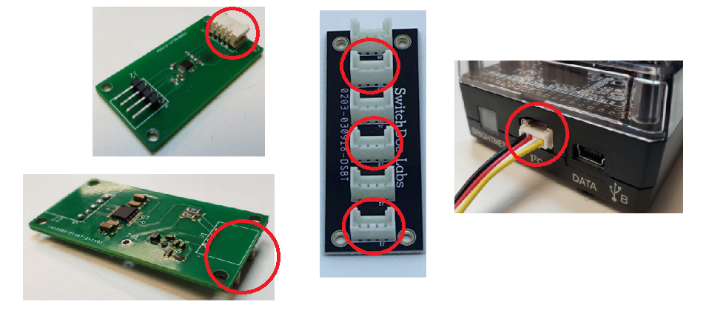

### 1.3.3. Oscilloscope Module

The oscilloscope does not use an external module. Instead, connect the breadboard to female grove cable into the IN2 port.

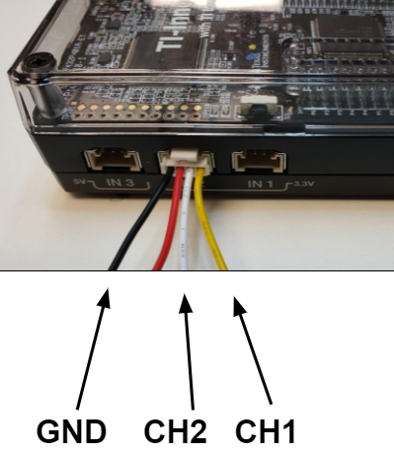

### 1.3.4. Logic Analyzer Module

Like the oscilloscope, the logic analyzer does not use an external module. Instead, you will connect to the logic analyzer using breadboard wires to the breadboard area of the TI Innovator Hub. Pins 1-8 are logic analyzer channels 1-8 and are referenced to the TI Innovator Hub ground.

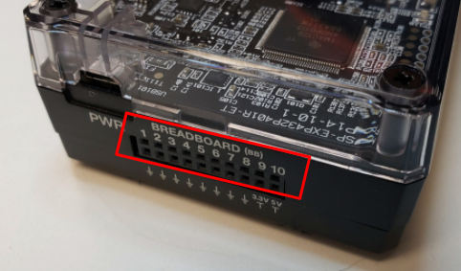

Once you have connected all the modules, you are ready to power on the device.

## 1.4. Power On

1. Connect the microUSB into the PWR port of the TI Innovator Hub.

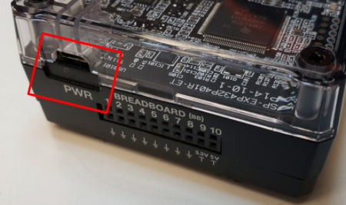

The microUSB cable can be connected to either a power brick or a computer USB port. If you plan to operate a circuit using the 3V3 or 5V breadboard connections that draws more than 200 mA, you will need to connect to a power brick from a wall socket.

1. You should see a red light on the TI Innovator Hub and after approximately five seconds you should see the green LED on the wifi module light up.
2. *Note: If the multimeter or function generator module must be connected when power is applied.*
3. You should now see a wifi connection called “ti82-team-12”.

Now that the device is powered on and ready to use, we will connect to the wifi access point provided by the wifi module.

## 1.5. Connecting to the Wireless Access Point

1. Go to your list of available wifi connections and look for “ti82-team-12”.
2. Click connect and type in the password “thisispassword”.
3. Wait for the computer to finish checking the connection. When you see “No Internet, secured”, you are ready to open the graphical user interface.

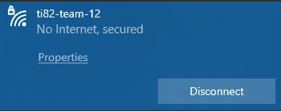

1. Open up a web browser and type in “daq.loca/” into the url bar. Hit enter and the graphical user interface should load.

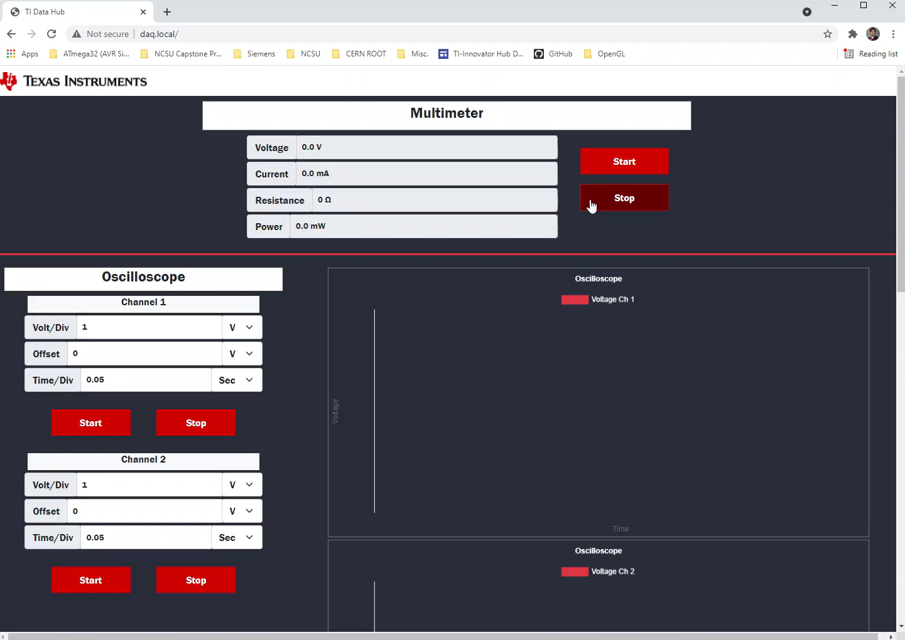

Now that the GUI is loaded, we will walk through the operation of the GUI.

## 1.6. Running the Graphical User Interface

### 1.6.1. Multimeter

The operation of the multimeter is fairly simple, press start to begin taking measurements and press stop to stop taking measurements. The multimeter only updates one value at a time and there is a delay between when the value changes and when it is accurately displayed in the GUI. The resistance is the only thing that is not directly measured by the multimeter and is described in a later section.

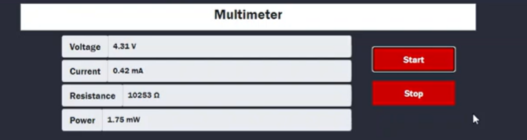

### 1.6.2. Oscilloscope

You can start and stop each channel of the oscilloscope independently. For each channel you can select the voltage per division, voltage offset, and time per division by typing the number into the text fields and pressing enter. The time per division is currently buggy and so only use values around 0.05 seconds per division. Though other values are possible, using too high or low a value may cause a hangup.

There are always 10 tick marks on the voltage axis. The volt/div sets the voltage per every two tick marks. The offset shifts the chart either up or down. This allows you to change the plot in a way to allow for viewing many different sizes of waveforms. Time per division changes the scaling of the time axis.

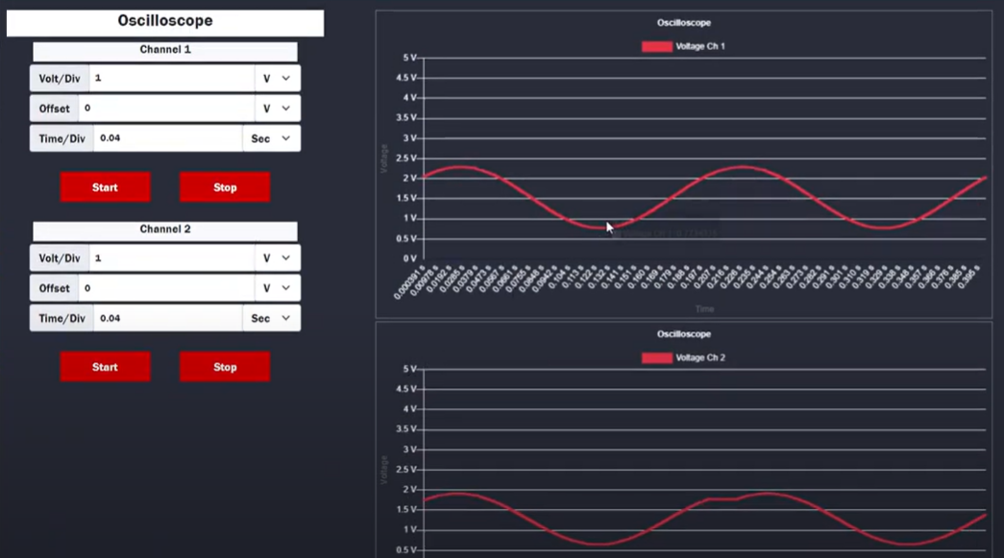

### 

### 1.6.3. Function Generator

The function generator has four channels available for use. Only one channel can be used at a time and it is planned to implement all four channels in future updates.

* Channel selects which channel is active and which pin has the voltage coming out of it.
* Type allows you to select between four different waveforms: square, sine, sawtooth, and DC.
* Frequency changes the frequency of the waveform.
* Amplitude changes the peak to peak voltage of the waveform.
* Bias changes the voltage offset of the middle of the waveform.

For example, a sine wave with an amplitude of 1V and with a bias of 1V would produce a sine wave that oscillates from 0.5 to 1.5V.

When you change channels, the previous channel settings are saved. Whenever a change is made to the waveform, you must press start to update the signal. For example, if you change the type from square to sine, it will not output a sine wave until you press start.

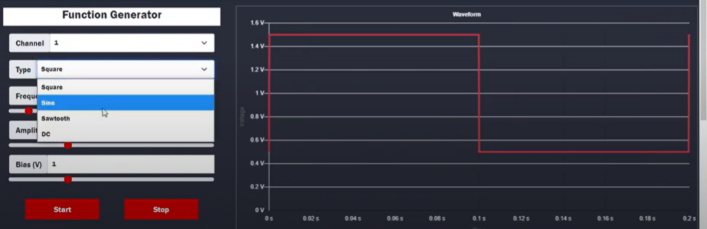

### 1.6.4. Logic Analyzer

The logic analyzer allows us to watch the changing of 8 bits simultaneously. You can turn on and off any channel you wish and can pause all 8 channels simultaneously. The logic analyzer does not trigger at this time and is planned for a future update. When the button is whited out, that means it is active, when red, that button is inactive.

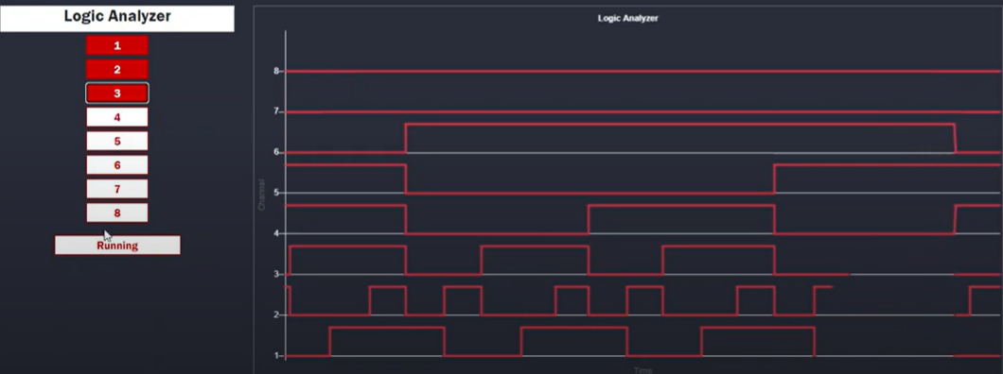

## 1.7. Data Acquisition: Multimeter

The four pins highlighted below are used to measure current, power, voltage, and resistance with the voltmeter. The ground pin is the ground reference for the VBUS pin. The VBUS pin is the measured voltage that is displayed in the GUI. VIN+ and VIN- are the current meter probes. Connect VIN+ to the positive side and VIN- to the negative side. *Note: If you connect it backwards, the current will not read properly in the GUI*. Negative current will be handled in a future update. The power is the current multiplied by the voltage, so if you want to measure power, you must measure the voltage and current in the same location.

The resistance measurement is not built into the multimeter and is instead calculated by ohm’s law with the current and voltage measurement. In order to measure the resistance of a resistor, you must measure the voltage across the resistor and the current through the resistor.

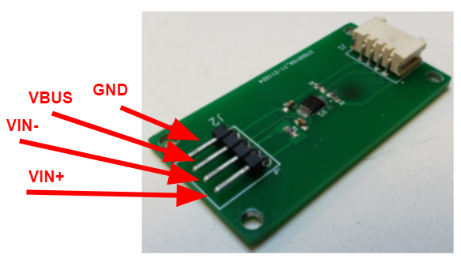

## 1.8. Data Acquisition: Oscilloscope

The photo below shows which wires are related to which parts of the oscilloscope. The oscilloscope is referenced to the TI Innovator Hub ground. The yellow wire is channel 1 and the white wire is channel 2. Once the wires are connected you can view the values using the oscilloscope GUI. The oscilloscope can only read values between 0V and 3V3. The red wire is not required, but can be used for 3V3 if needed. This red wire is limited to 100 mA.



## 1.9. Data Acquisition: Logic Analyzer

Pins 1-8 will read low when 0V is applied and high when 3V3 is applied. Voltages that are between 0V and 3V3 are undefined. Do not apply greater than 3V3. When nothing is applied to the pin it registers low. When using the logic analyzer each pin is referenced to ground.



## 1.10. Driving a Circuit: Function Generator

The function generator is operated from the function generator GUI. Using the image below, you connect a breadboard wire from whichever channel you want to use to where in your circuit you want the waveform applied too. All four channels can be hooked up simultaneously, but only one channel will operate at a time. The function generator channels are referenced to the ground pin shown below. The function generator can output signal voltages between 0V and 5V.

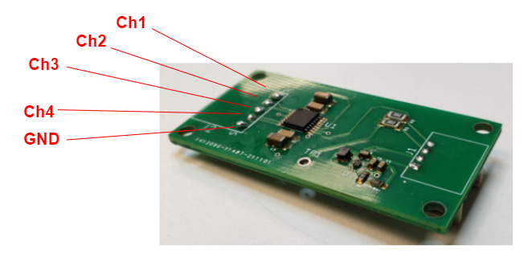

# 2. Additional Setup for Prototype (For Mark)

## 2.1. Introduction

This section of this document is meant to help those who are working behind the scenes with the unrefined product. As it stands, the TI Innovator HUB Data Acquisition Tool is still in its prototype stage. The user guide above shows how to operate the product. This section is meant for those with a deeper technical knowledge and those with the intention of further developing the product. This section covers how to set-up the device for the first time using Arduino and Code Composer Studio.

## 2.2. Setting up ESP32 Firmware (Arduino)

1. First we must flash the firmware to the ESP32 (wifi module). This is done via Arduino and this project was completed with Arduino 1.8.16 on Windows 10. Download and install Arduino.
2. Install ESP32 board via board manager. Follow this guide: [ESP32 in Arduino](https://docs.espressif.com/projects/arduino-esp32/en/latest/installing.html).
3. You should now have this option in your board manager:

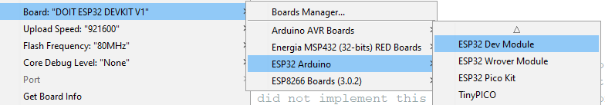

We chose to use DOIT ESP32 DEVKIT V1 because that is what our development board is.

1. Then you must install the ESPAsyncWebServer and AsyncTCP libraries in Arduino. These can be found at [ESPAsyncWebServer](https://github.com/me-no-dev/ESPAsyncWebServer) and [AsyncTCP github](https://github.com/me-no-dev/AsyncTCP). You will need to download the GitHub zip and install it. Use this guide: [GitHub -> Arduino IDE](https://www.digikey.com/en/maker/blogs/2018/how-to-install-arduino-libraries).
2. Now, we will need to wire up the wifi module. Look at the image below:

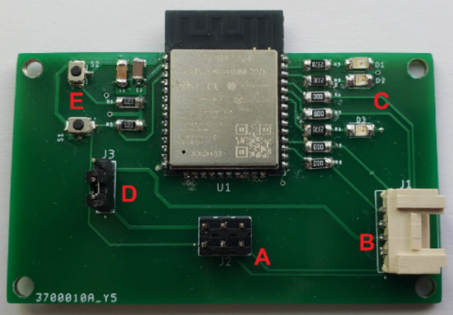

This is not the final iteration of the wifi PCB, make sure you are using the one that has only one grove connector. The PCB with two grove connectors is connected differently.

1. Connect a grove cable from B on the wifi PCB to the “OUT1” port on the TI Innovator HUB. This will provide a ground reference from the HUB.
2. Ensure that the jumper is on the bottom two pins at D on the wifi PCB.
3. Connect 3V3 from the HUB breadboard to the top left pin of the 2x3 male header at A on the wifi PCB.
4. Connect the programmer ground to the top middle pin at A on the wifi PCB.
5. Connect the programmer RX to the bottom middle pin at A on the wifi PCB. This pin goes to the ESP TX0.
6. Connect the programmer TX to the bottom left pin at A on the wifi PCB. This pin goes to the ESP RX0.
7. Power on the TI Innovator HUB.
8. It is assumed that the programmer drivers are installed and it is properly operating. Determine which COM port the programmer is using and then set the serial to that port in the Arduino IDE.

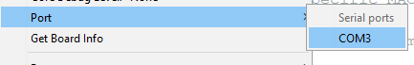

1. *Optional:* You can install a serial terminal and set it to 115200 baud to check the operation of the wifi module. A good serial terminal is [Tera Term](https://ttssh2.osdn.jp/index.html.en). You should see a boot message when you press the lower push button (reset) at E on the wifi PCB. If you hold the upper push button (boot) while pressing the reset button, you should receive a “waiting for download” message. This means that the wifi module is in serial bootloader mode.

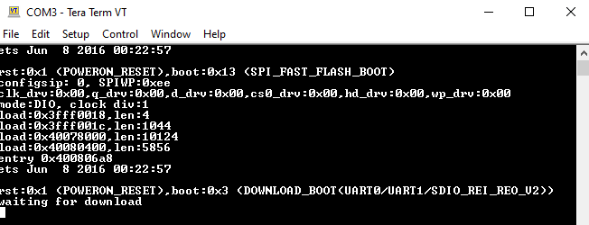

1. Now, the IDE should be configured and the programmer connected to the wifi module. Unfortunately we do not have any photos of the programmer connected to the wifi module.
2. If you have a serial terminal open, close it. The programmer cannot be used both in the serial terminal and by the Arduino IDE.
3. Open the esp32_firmware.ino sketch from the GitHub repository ([Link](https://github.ncsu.edu/cedenni2/ti_82/tree/master/esp32_firmware)) and upload the sketch. You should see the image below:

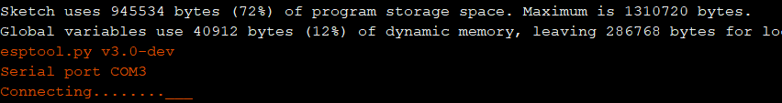

1. If the ...___...___ does not stop, then press and hold the upper push button (boot) until it begins uploading, which will look like this:

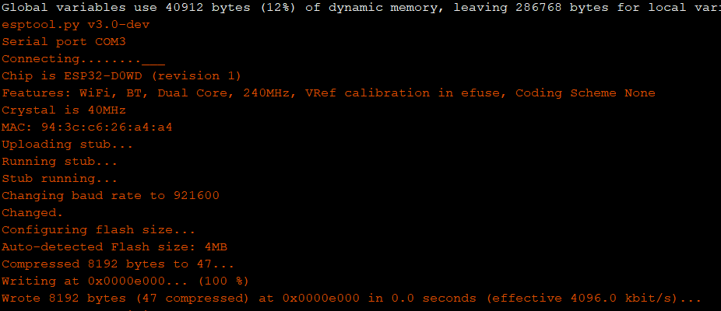

1. Once the upload is complete you will get this message:

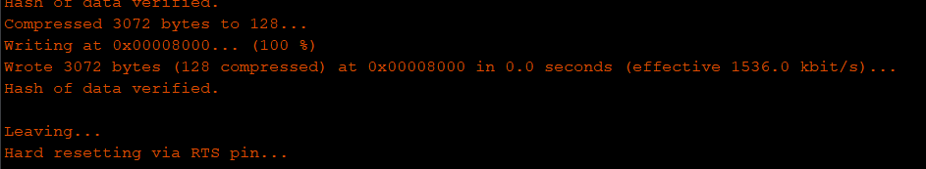

1. Press the reset button and if you have a serial terminal, open it back up to view the ESP32. You should see the boot message along with the ESP32 IP address. The green LED will turn on after approximately 5 seconds. When the green LED is lit, check for an SSID called “ti82-team-12”. This means that the setup was successful.
2. If you receive an error when uploading, check the following:
   1. The COM port of the programmer is not being used by another program.
   2. The arduino IDE is set to the correct serial port.
   3. The programmer drivers are installed.
   4. The programmer is connected correctly.
   5. The ESP32 is receiving power from the TI HUB.
3. If the ...___...___ does not stop and pressing the boot button does not begin upload, check to make sure that the boot pin (GPIO-0) is going low when the push button is pressed. The pin to check is highlighted below:

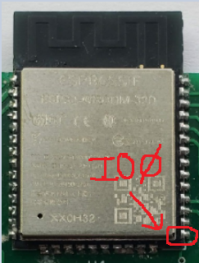

## 2.3. Setting up MSP432P401R Firmware (Code Composer Studio)

1. The TI Innovator HUB is a MSP432P401R on the inside. Since the firmware is not a .hub sketch, as of right now the firmware must be flashed using code composer studio. This project was done using CCS 10.4.
2. Download and install code composer studio ([CCS](https://www.ti.com/tool/CCSTUDIO)).
3. Follow this quickstart guide for the MSP432 and ensure that you can run a simple program on the device ([Quickstart MSP432](https://software-dl.ti.com/simplelink/esd/simplelink_msp432_sdk/1.40.01.00/docs/simplelink_mcu_sdk/Quick_Start_Guide.html)).
4. If not already installed, install the driverlib library ([driverlib](https://www.ti.com/tool/MSPDRIVERLIB)).
5. Once CCS is installed, open CCS and import the project files at [TI Innovator Hub Firmware](https://github.ncsu.edu/cedenni2/ti_82/tree/master/ti_innovator_hub_firmware/ti_hub_daq).

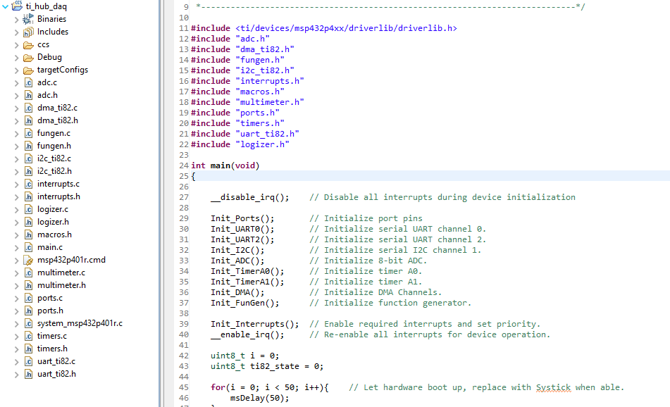

1. Connect the TI Innovator HUB using the microUSB port where it has PWR printed. You should have connected and tested it during the quickstart guide.
2. With the TI Innovator HUB connected, upload the program to the TI Innovator HUB. The TI Innovator HUB is now ready to be used with the modules.
3. If you need to revert the HUB back to its default firmware use this [link](https://education.ti.com/en/software/details/en/EFD1D3762FE941FAA21E774D8520AEF0/TI-Innovator_Hub_Update_SW).
4. If you receive an error stating that the driverlib.h path could not be found, then the driverlib package is not installed correctly.

If you have downloaded the firmware for both the ESP32 and MSP432, wifi module and TI Innovator HUB, then you are ready to start the user guide.

# 